**Moon and Cake Team Roles**:

Max Yeh: Product Owner

Yao-Wen Chang

Jinson Wu

Yi-Chia Wu: Scrum Master (rotated)

Ya-Ru Yang

**Customer Meeting Date/Time/Place**:

weekly meeting: 9/29 via Zoom (10:00-11:00am every Thursday via Zoom)

**Since we have midterms this week, the meeting on 10/6 was cancelled after the discussion with the client.**

**Feedback from the Client (mainly from the meeting on 9/29):**

* Third-party authentication through Google was the primary task. Other linkages, e.g., Twitter and LinkedIn, were desired, but not required
* Homepage and login/signup page were free to design as long as they looked good
* Wish to have admins that could check the appropriate questions for students to test themselves
* Had database that stored the grades and profile history

**Current Working Stories**:

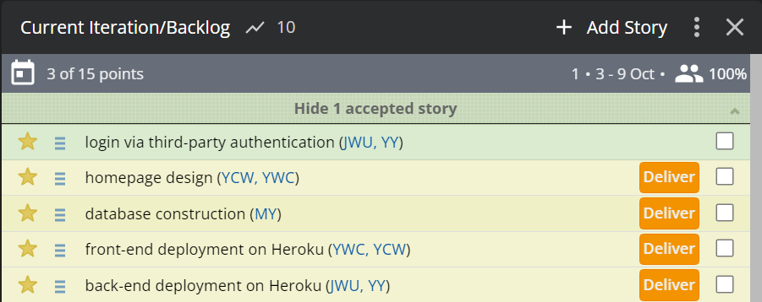

* user stories pick from iteration-0: none
  + Latest details of the prototype were proposed in the meeting last time. There were some revisions toward the implementation of the website. The client was eager to firstly focus on third-party authentication and homemade design. Therefore, we attempted to accomplish these features in advance instead of the stories created in iteration-0
  + New user stories were added which could better describe the requirement from the client.
  + This iteration creates a user login interface and system, which can identify different users while logging into the website. One is able to have login/signup options by email or through Google.
  + Primary login/signup page is shown below with the functions demonstrated above. Internal integration is still progressing. Plan to be completed before next week
  + Database linked with the user profile is under construction. We now emphasize on the combination of backend and add-on profiles within Django framework

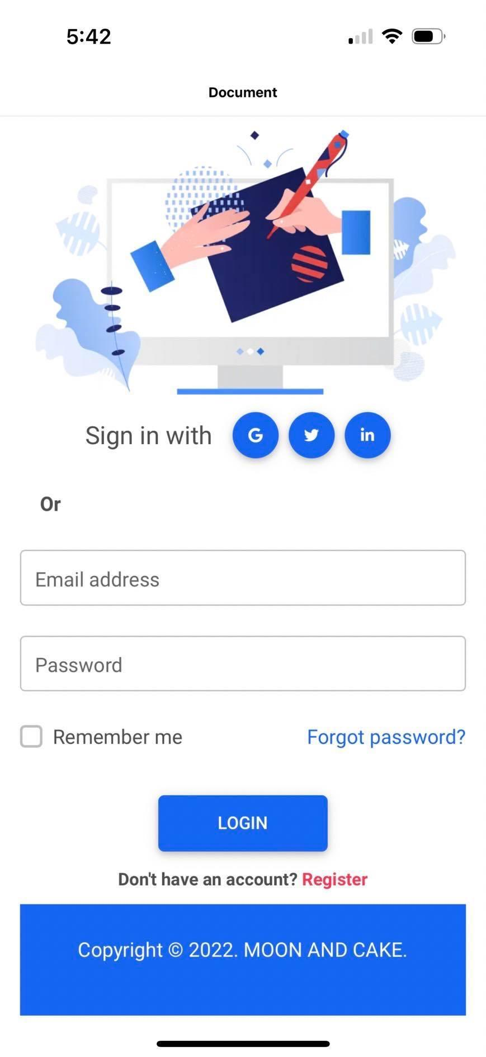

* Test case:
  + Cucumber and RSpec test cases:
    - this will be created after connecting the frontend and backend.
  + BDD: test an application's behavior from the end user
    - there will be two types of users, one is logged by google account and the other is by email-signup account.
    - Different login methods will lead to different text after login (pop-up message then redirect).
  + TDD: testing smaller pieces of functionality
    - type 1: enter username and password
    - type 1: frontend passes the information and interacts with database via backend service
    - type 1: store user information in database
    - type 2: able to access google account (into account selection page)
    - type 2: use google account to login and fetch the basic information from the platform
    - different user types and username give different result (text show on the page)
  + Evaluation (in the next several iterations)
    - Database reliability test after fully constructed
    - Code verification judgement respectively from the model and conventional standard
    - Front-end function test
* UML class diagram

